To: Public School Administrators; Charter School Leads; Food Service Directors of Schools Participating in the School Nutrition Programs
From: Arleen Ramos-Szatmary, M.S. 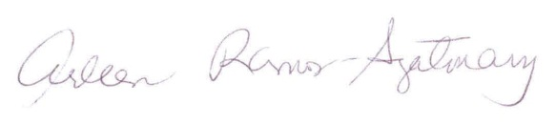
Coordinator
School Nutrition Programs

Date: July 27, 2018

Subject: National School Lunch Program – State Match

The State Lunch Match funds have been fully expended for the state fiscal year ended June 30, 2018.

Reimbursements for the State Lunch Match will resume, effective on July 2018 vouchers.

If you have any questions, please contact Danielle Fernandez at 609-984-1090.

